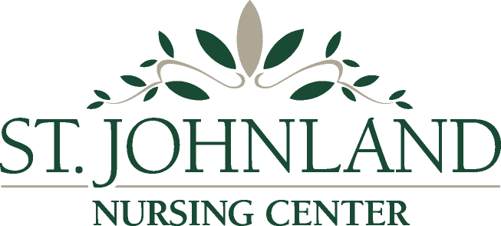

June 26, 2022

Dear Resident and Family Members,

We are writing to inform you that we have received notification today that one resident has tested positive for COVID-19. Please be advised that the facility is in outbreak status. We are currently conducting contact tracing, and will test any residents and staff members who may have been exposed at least twice in the coming days to ensure negative results. If this affects your loved one, his/her designated representative will have been notified by phone.

As a reminder, NYS Department of Health continues to require all visitors to present a negative SARS-CoV-2 test result prior to visiting your love one. Negative test results must have been received from tests administered no more than one day prior to visitation for antigen test (rapid) and two days prior for a PCR. If you do not have access to testing outside of our facility, we have test kits and will provide you with one before your visit. Please be aware that testing takes approximately 15 minutes, and may impact the time you have to spend with your loved one.

Our preferred visiting hours, for the benefit of our residents, are between 10:00 AM and 8:00 PM. Surgical or better masks (no cloth masks) are required to be worn at all times while in the facility, including during your visit with your loved one. Sanitize your hands often, especially when entering and leaving our facility, and maintain physical distancing wherever possible. Please refrain from visiting if you do not feel well, if you have tested positive for COVID-19, or if you know you have been exposed to COVID.

All visitors are encouraged to be vaccinated, and boosted when eligible, to reduce the risk of contracting and spreading COVID-19, as well as to reduce the severity of illness if infection occurs.

Thank you and we appreciate your cooperation.

The St. Johnland Care Team

